

Tourist Assistant Website

Project Management Plan

**Project Code: TAW**

**Document Code: TAW_PMP – v0.1**

**Ha Noi, September 20th 2016**

Record of Change

*A - Added M - Modified D - Deleted

|  |  |  |  |  |
| --- | --- | --- | --- | --- |
| Effective Date | Changed Items | A* M, D | Change Description | New Version |
| 2016/09/20 | Create new | A | Create document | 0.1 |
|  |  |  |  |  |
|  |  |  |  |  |
|  |  |  |  |  |
|  |  |  |  |  |
|  |  |  |  |  |
|  |  |  |  |  |
|  |  |  |  |  |
|  |  |  |  |  |
|  |  |  |  |  |
|  |  |  |  |  |
|  |  |  |  |  |
|  |  |  |  |  |
|  |  |  |  |  |
|  |  |  |  |  |
|  |  |  |  |  |
|  |  |  |  |  |
|  |  |  |  |  |
|  |  |  |  |  |
|  |  |  |  |  |
|  |  |  |  |  |

Signature Page

**ORIGINATOR:** Phan Thanh Tùng Date: 2016/09/20

*Member*

**REVIEWERS:** Nguyễn Xuân Thu Date: 2016/09/23

*Leader*

**APPROVAL:** Bùi Đình Chiến Date: 2016/09/25

*Supervisor*

Table of Contents

Record of Change 2

Signature Page 3

Table of Contents 4

Definitions and Acronyms 6

1 Project OverView 7

1.1 Project Description 7

1.2 Scope and Purpose 7

2 Project Organization 8

2.1 Organizational Structure 8

2.2 Software Process Model 10

3 Project Schedule 11

3.1 Milestone and Deliverables 11

3.2 Task Sheet 11

4 Risk management 13

4.1 Risk Categories 13

4.2 Risk Register 14

4.3 Probability/Impact matrix 16

4.4 Closing a Risk 16

5 COmmunication management 17

5.1 Collection and filing structure for gathering and storing project information 17

5.2 Technologies or access method use for communications 17

5.3 Escalation procedures 18

6 CI Identification & Naming convention 18

7 Tool and infrastructure 19

7.1 Software 20

7.2 Hardware 20

7.3 Others infrastructures 20

Definitions and Acronyms

|  |  |  |
| --- | --- | --- |
| Acronym | Definition | Note |
| TAW | Tourist Assistant Website |  |
| PMP | Project Management Plan |  |

# Project OverView

## Project Description

|  |  |  |  |  |
| --- | --- | --- | --- | --- |
| Project Name | * **Tourist Assistant Website** | | | |
| Project Code | * TAW | | | |
| Project Manager | * Nguyen Xuan Thu | | | |
| Project Category | 🗹 New Development | | 🞎 Maintenance | 🞎 Other |
| Business domain: | * Tourist Assistant Website | | | |
| Scope and Objective | Objective: Some advanced purposes when developing Tourist Assistant:   * Reduce time to search information * Intensify the detail of website when providing information to users. * Have a little part in popularizing tourism of cities or countries. * Contribute to improving the quality of service through the system of objective evaluation and feedback. * Bring the most convenience to travelers when they prepare for sightseeing to some essential locations in the city.   Product: A website contains following functions   * Search * Register * User suggest new place and evaluate the place * User manage favorite place and see their favorite places in map.   Scope:   * Target user for this website is tourist who travel to Vietnam | | | |
| Project start date: 2016/09/05 | | **Expected end date**: 2016/12/16 | | |
| Planned duration | 102 Days | | | |

## Scope and Purpose

The scope of this project includes these stages:

* Develop user requirement and software requirement specification.
* Develop architecture and detailed design documents.
* Coding and unit test.
* Develop test case and execute combination test.

# Project Organization

## Organizational Structure

**TABLE 2-1 Role and Responsibilities**

|  |  |  |
| --- | --- | --- |
| Role | Responsibility | Full Name |
| Supervisor | * Provide document template. * Review deliverables. * Review project status. * Resole escalated issues. | Bui Dinh Chien |
| Project manager | * Develop project plan. * Manage project stakeholders, project team and resolve conflicts. * Manage project schedule, project risk. * Communication with members and supervisor, include weekly plan, weekly status report, hold meetings and assure to submit reports to supervisor on schedule. * Manage document synchronization in project. * Task assignment and tracking. | Nguyen Xuan Thu |
| Requirement Analysis Team | | |
| Team Leader | * Review and tracking | Nguyen Xuan Thu |
| Team Member | * Create screen flow and use-case diagram. * Define use-case description. * Define screen flow description | Le Trong Viet  Phan Thanh Tung  Chu Dai Cao Cuong |
| Design Team | | |
| Design Leader | * Applying design framework for project. * Supporting to design screens. | Phan Thanh Tung |
| Designer | * Involve designing screens. | Phan Thanh Tung  Pham Nguyen The Khang  Nguyen Hai Sy |
| Develop Team | | |
| Technical Leader | * Building project frame. * Researching to resolve issues. | Pham Nguyen The Khang |
| Developer | * Studying technique. * Involve to coding function. * Self-review source code and executing unit testing | Pham Nguyen The Khang  Nguyen Hai Sy |
| Test Team | | |
| Test Leader | * Manage test results recoding. * Ensuring the product the certain standards of quality from requirement. | Le Trong Viet |
| Tester | * Responsible for test execution, defect logging. | Le Trong Viet  Nguyen Xuan Thu  Chu Dai Cao Cuong |

## Software Process Model

The process model used for developing this project is waterfall model.

“The **waterfall model** is a [sequential](https://en.wikipedia.org/wiki/Sequence) (non-iterative) [design](https://en.wikipedia.org/wiki/Design) process, used in [software development processes](https://en.wikipedia.org/wiki/Software_development_process), in which progress is seen as flowing steadily downwards (like a [waterfall](https://en.wikipedia.org/wiki/Waterfall)) through the phases of conception, initiation, [analysis](https://en.wikipedia.org/wiki/Analysis), [design](https://en.wikipedia.org/wiki/Software_design), construction, [testing](https://en.wikipedia.org/wiki/Software_testing), [production/implementation](https://en.wikipedia.org/wiki/Implementation) and [maintenance](https://en.wikipedia.org/wiki/Software_maintenance).”

Source: https://en.wikipedia.org/wiki/Waterfall_model

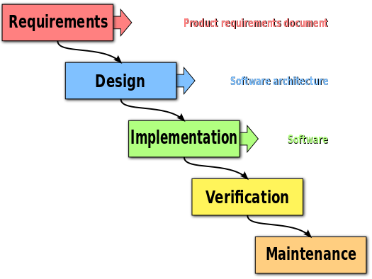

*Figure 2.2: Waterfall Model*

We decided to choose waterfall development software process model by the seasons below:

* The requirement is quite clear. It is appropriate for this process model.
* Waterfall model is easy to implement and manage.
* This is an important project in a short term, so we do not have much time for other process model like Spiral.

# Project Schedule

## Milestone and Deliverables

**TABLE 3-1 Milestone and Deliverables**

|  |  |  |  |  |
| --- | --- | --- | --- | --- |
| No | Deliverable/ Milestone | Delivery Date | Delivery Location | Delivery type |
| 1 | Capstone Project Register | 2016/09/05 | University | Hard and soft copy |
| 2 | Report 1 | 2016/09/12 | Supervisor | Soft copy |
| 3 | Report 2 | 2016/09/26 | Supervisor | Soft copy |
| 4 | Report 3 | 2016/10/10 | Supervisor | Soft copy |
| 5 | Report 4 | 2016/11/7 | Supervisor | Soft copy |
| 6 | Report 5 | 2016/11/21 | Supervisor | Soft copy |
| 7 | Report 6 | 2016/12/05 | Supervisor | Soft copy |
| 8 | Final Report | 2016/12/10 | Supervisor | Soft copy |
| 9 | All Project resource | 2016/12/14 | University | Hard and soft copy |

## Task Sheet

The tasks and duration of it is showed below:

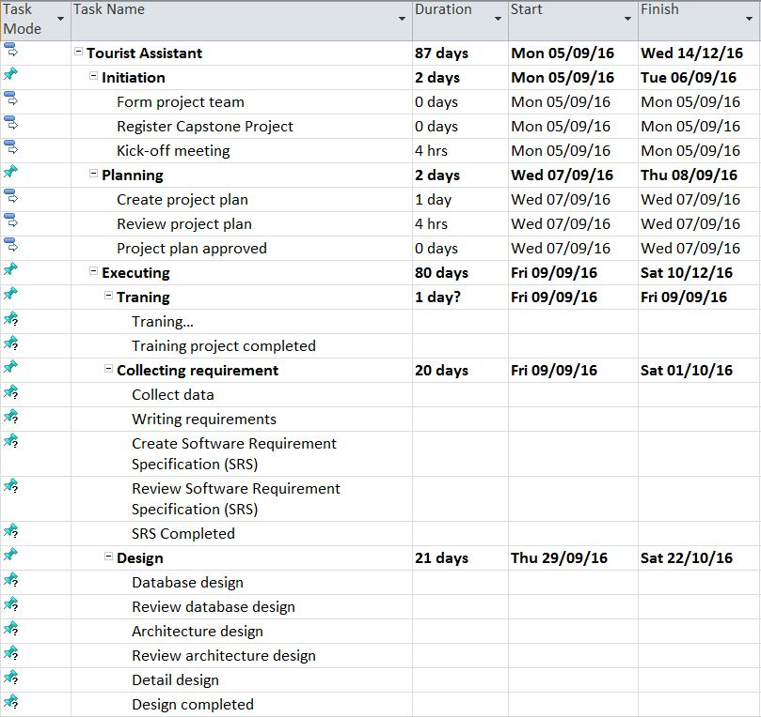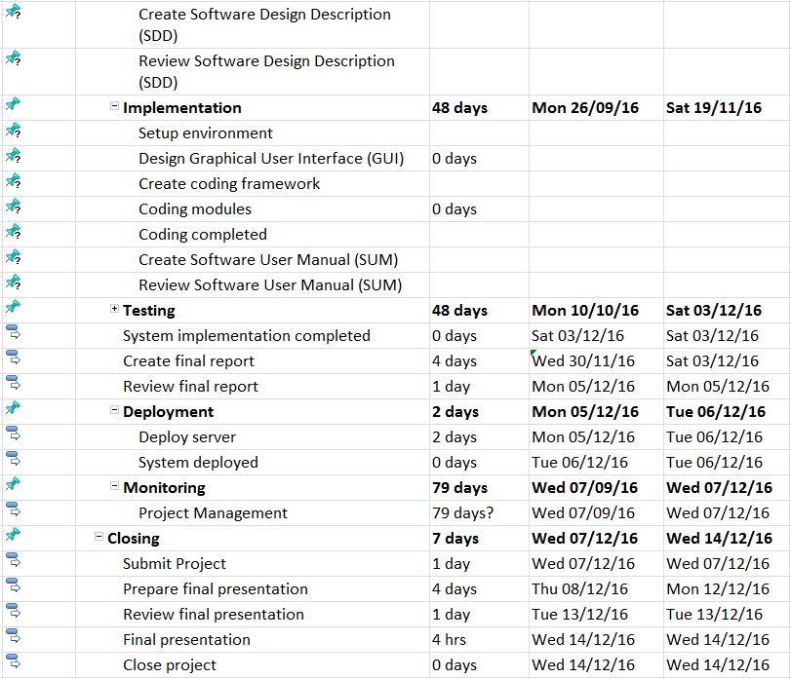

# Risk management

## Risk Categories

**TABLE 4-1 Risk Categories**

|  |  |  |
| --- | --- | --- |
| **Category** | **Sub-category** | **Acronym & Abbreviation** |
| **Technical** | Requirement Definition | T-RD |
|  | Technology | T-T |
|  | Complexity and Interfaces | T-CI |
|  | Performance and Reliability | T-PR |
|  | Design | T-D |
|  | Quality | T-Q |
| **Management** | Estimating | M-E |
|  | Human Resources | M-HR |
|  | Communication | M-Cm |
|  | Source | M-S |
|  | Controlling | M-Ct |
| **External** | Market | E-M |
|  | Weather | E-W |
|  | User | E-U |

## Risk Register

**TABLE 4-2 Risk Register**

|  |  |  |  |  |  |  |  |
| --- | --- | --- | --- | --- | --- | --- | --- |
| ID | Description of risk | Category | Impact | Root Cause | Avoidance plan | Contingency plan | Fallback plan |
| 1 | Misunderstanding requirements | T-RD | Affect the team quality and delay task | Poor requirement definition | Team have to  define clear requirement | Team lead need show clearly requirement for each other. | Ask team member. |
| 2 | The processes does not meet their deadline | M-Ct | Affect the team member’s attitude and delay task | Poor control | Research carefully about how to control team | Increase work performance | Operate a lot of work at the same time |
| M-E | Poor estimate | Ask who will work to estimate |
| 3 | Conflict between team member | M-Cm | Affect the team member’s attitude. | there is a disagreement over project issues | Define clear team’s goals.  Understand others. | Team member listen to idea of each other and find out solutions | Change the team ‘s workplace |
| 4 | A team member’s absence | M-HR | Affect the team member’s attitude and delay task | Personal reason | Motivate members. Define clear the project schedule | Other members replace that member’s work | Apply team punishment rules |
| 5 | Low team member’s motivation | M-Cm | Affect the team member’s attitude and delay task | Personal reason | Interact with others more | Conduct a meeting so that the team members can express their opinions and find out solutions. | Take responsibility in front of the team. |
| Team ‘s workplace | Organize team building so that team member can get well to each other |
| 6 | Training process is not effective | M-HR | Affect the team member’s attitude and delay task | Personal reason | Each member needs to be active to do research by themselves and writes report. | Attend more training meeting. | Hire someone to help with technical training |
| 7 | Low data  quality | T-Q | Have influence on the schedule and project quality | Team’s ability is low | Build data in a logical way.  Ask teacher for help to check the quality | Fix data immediately | Decrease unnecessary data |
| 8 | Poor unit test and test case | T-Q | Affect the Project quality | Test is not enough | Each member needs to do research and work carefully. | Increase work performance | Ask for other people’s help to test |
| 9 | Technology components aren't fit for purpose | T-T | Affect the Project quality | Technology components are low quality. | Improve quality of technology components | Change technology components |  |

## Probability/Impact matrix

The probability and impact of occurrence for each identified risk will be assessed  
by the project manager, with input from the project team using the following  
approach:

* **Probability**
* High – Greater than <70%> probability of occurrence.
* Medium – Between <30%> and <70%> probability of occurrence.
* Low – Below <30%> probability of occurrence.
* **Impact**
* High – Risk that has the potential to greatly impact project cost, project  
  schedule or performance.
* Medium – Risk that has the potential to slightly impact project cost, project schedule or performance.
* Low – Risk that has relatively little impact on cost, schedule or performance.

**TABLE 4-3 Probability/Impact matrix**

|  |  |  |  |  |
| --- | --- | --- | --- | --- |
| **Probability** | **High** |  |  | Risk 2 |
| **Medium** | Risk 8 | Risk 6, Risk 9 | Risk 7 |
| **Low** | Risk 4 | Risk 1 | Risk 3 |
|  | **Low** | **Medium** | **High** |
| **Impact** | | | |

## Closing a Risk

A risk will be considered closed when it meets the following criteria:   
- Risk is no longer valid.  
- Risk Event has occurred.  
- Risk is no longer considered a risk.  
- Risk closure at the direction of the Project Manager.

# Communication management

## Collection and filing structure for gathering and storing project information

Tourist Assistant project will be divided into a series of small tasks, each task will be assigned to team members by Project Leader and depend on difficulty, and Project Leader will assign deadlines for each task. We will have a meeting every Tuesday, Thursday and Saturday to report the progress of the whole team’s tasks. If there is any issue, we will discuss and find solution together.

For each milestone in this project, there is a report that stored project information of the previous process.

Only Leader can access theses file after storing it into Google drive, other team member can view but cannot modify or copy. After create a report, it will be reviewed by supervisor in face-to-face meeting at the next Saturday.

A final report which storing all previous reports will be created at the last project process.

## Technologies or access method use for communications

**TABLE 5-1 Communication tools.**

|  |  |  |
| --- | --- | --- |
| **Technologies or access method** | **Tool Name** | **Purpose** |
| Email and message | Gmail | Contact with supervisor |
| Facebook | Keep track of team process |
| Video call | Skype | Online meeting |
| Mobile phone | Cellphone | Contact directly with other stakeholders in an emergency situation |
| Collaboration tool | Tortoise SVN | Managing source code |
| Google Drive/Facebook Group | Managing document |

## Escalation procedures

**TABLE 5-2 Escalation procedures.**

|  |  |  |  |
| --- | --- | --- | --- |
| **Priority** | **Definition** | **Decision Authority** | **Timeframe for Resolution** |
| **Priority 1** | High impact which may stop all process of the project. | Supervisor | Within two business days. |
| **Priority 2** | Medium impact which may cause some scheduling difficulties with the project. | Project Leader | Within two business days. |
| **Priority 3** | Insignificant impact to project but there may be a better solution. | Project Leader | Work continues and any recommendations are submitted via the project change control process. |
| **Priority** 4 | Technical impacts which may cause stop a part of the project. | Project Leader | Within three business days.  Work continues with another project part. |

# CI Identification & Naming convention

|  |  |  |
| --- | --- | --- |
| **No** | **Configuration Items** | **Naming convention** |
| **Project Management** | | |
| **1** | Project Management Plan | TAW_Project Management Plan _v[version number]  For example: TAW_Project Management Plan_v0.1 |
| **Requirement & Design** | | |
| **2** | Software Requirements  Specification | TAW_Software Requirements Specification_v.[version number]  For example: TAW_Software Requirements Specification_v1.0 |
| **3** | Software Design Description | TAW_Software Design Description_v.[version number]  For example: TAW_ Software Design Description_v1.0 |
| **4** | Screen Design | TAW_Screen Design_v.[version number]  For example: TAW_Screen Design_v1.0 |
| **5** | Data Design | TAW_ Data Design_v.[version number]  For example: TAW_ Data Design_v1.0 |
| **Source Code** | | |
| **6** | Source Code | TAW_Source Code_ v.[version number] [Tested/Untested] For example:  TAW_Source Code_v1.0 Tested |
| **Support Document** | | |
| **7** | User Manual | TAW_User Manual_v.[version number]  For example: TAW_User Manual_v.[version number] |
| **Test** | | |
| **8** | Test Plan | TAW_Test Plan_v.[version number]  For example: TAW_Test Plan_v1.0 |
| **9** | Test Case | TAW_Test Case_v.[version number]  For example: TAW_Test Case_v1.0 |
| **10** | Test Result | TAW_Test Report_v.[version number]  For example: TAW_Test Report_v1.0 |
| **Process** | | |
| **11** | Guideline | TAW_ [Name Of Guideline] Guideline_v.[version number]  For example: TAW_Unit Test Guideline_v1.0 |
| **12** | Convention | TAW_[Name Of Convention] Conventions_v.[version number]  For example: TAW_Coding Conventions_v1.0 |
| **13** | Checklist | TAW_[Name Of Checklist] Checklist_v.[version number]  For example: TAW_Review Code Checklist_v1.0 |
| **File Type** | | |
| **14** | MS Word | *.doc, *.docx |
| **15** | MS Excel | *.xls, *.xlsx |
| **16** | MS PowerPoint | *.ppt, *.pptx |
| **17** | MS Project | *.mpp |
| **18** | Enterprise Architect | *.eap |
| **19** | Images | *.png or *.jpg or *.jpeg or *.bmp or *.gif |

# Tool and infrastructure

Below is the list of tools and infrastructure requirements needed for development environment.

## Software

**TABLE 7-1 Software needed for project**

|  |  |  |
| --- | --- | --- |
| **Category** | **Software Name** | **Version** |
| **Operating system** | Microsoft Windows | 10 |
| **Office tools** | Microsoft Office | 13 |
| **Task tracking** | Microsoft Excel | 13 |
| **Design tools** | Adobe Photoshop | CS6 |
| **Database tools** | Microsoft SQL Server | 2008 or higher |
| **Development Framework** | Spring Framework | 3.1.1 |
| **Development Tools** | Spring Tool Suite | 3.6.3 |
| **Source version control** | Tortoise SVN | 1.9.4 |
| **UI design tool** | Justinmind Prototyper | 6.5.2 |

## Hardware

* Personal computer for developing and testing with the minimum configuration:

4GB RAM, 500GB of hard disk, Intel Core i3.

* Internet network connection with minimum speech 512kbit/s

## Others infrastructures

* A room for team’s meeting.
* Internet and mobile phone services are needed for communication.